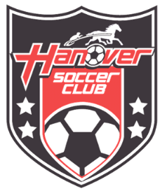

August 29, 2022

Dear HSC Community,

I am thrilled to officially announce that after 30+ years at the 101 Kindig Lane, Utz field residence the Hanover soccer club has found our next partner to keep youth soccer in Hanover.

We have partnered with Clark’s of America right down the street at 355 Kindig Lane (at the corner fields at Kindig and Oxford Avenue) for our next home field location!

We will conclude our Fall 2022 season at Utz field location as we begin the work of transitioning the Clarks fields, used previously for corn, to soccer fields and parking.

We are removing excess rock and corn stalk debris, and seeding in the next two weeks. We have an engineer completing plans for requesting access onto the field from Oxford Avenue that we’ll take to the township for approval as soon as possible.

There will be opportunities for your help in the coming weeks with things such as packing up the contents of our sheds and removing the chain link and top rails of our existing fencing for reuse at the new fields. It sounds like a great excuse for a pizza party!

Mostly, we are forever grateful for the decades of time and space afforded to us by our current partner Utz Brands and love to think of how many kids were introduced to our sport (and even refereeing!) on those fields. Now, we turn toward our next endeavor and know that we have a bright future at the Hanover Soccer Club and that our legacy will continue!

In soccer,

Amy Redding, President
Hanover Soccer Club

